REAL ESTATE AUCTION
111 N 11th Street, Rogers, AR
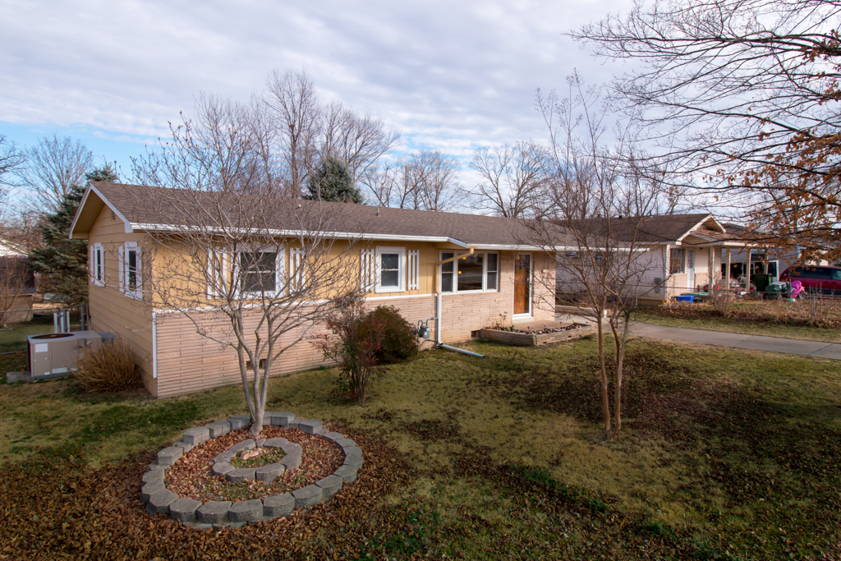
Fri. March 18th, 2016, 1PM
Directions: E on Walnut/N. on 11th.
Description
Completely remodeled home. Solid wood floors, new heat/ac, newer roof, stainless appliances, convection ovens, double door fridge, Deco new fixtures, carport, laundry room, over sized fenced yard, storage building, work shop building, workshop on house, sun room, mud room, new baths, brick & wood, near shopping & lake. House will be offered for auction on March 18th at 1 pm. Offers encouraged prior to auction. Full commission to buyer's agents. See website or contact us for bidder packet or for showing. Buyers agency full commission is paid at 3% on either traditional or auction sale method
There is a 10% BUYERS PREMIUM
- 10 % Down day of Auction non refundable w/balance paid at closing
- Closing to be within 30 days of Auction Date
- Seller to provide title insurance
- Properties selling “AS-IS”
- Auctioneer is a licensed real estate agent in the State of Arkansas
- Announcements made Auction Day take precedence over advertised material
View this listing online: metcalfauctions.com, MLS# 1008633

Terry Metcalf Carlette Metcalf
AALB# 1457 AALB# 2372
PRI,BAS,ASEA ISA.CAS,CAGA.ASEA,USPAP,PRI,BAS
(479) 409-3218 (479)381-3144 metcalfauctions.com Accredited Antique Appraiser



